**Implementing .gitignore**

1. Created

* debug.log file
* log folder using touch and mkdir commands

1. Verified whether the files and folder is created or not, using, ls -l
2. Created .gitignore file using nano command
3. Added rules to ignore which files and folders in the nano editor.
4. Checked the git status to confirm everything
   1. Debug.log
   2. Log/ are not shown in untracked files, as they match the rules in .gitignore and hence, they are ignored by git.

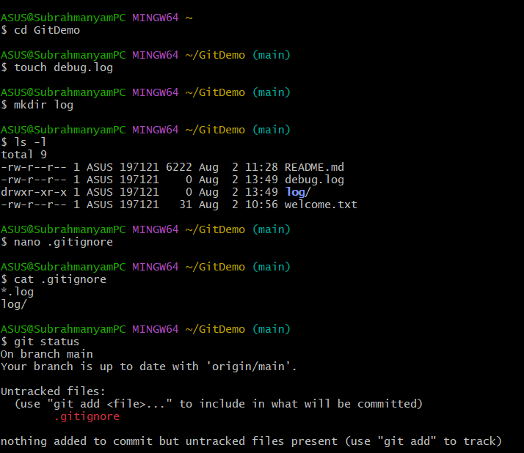

**The nano text editor**

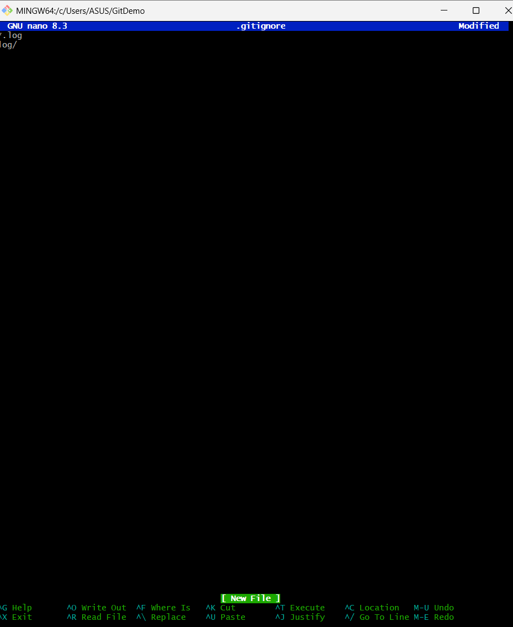

**Staged the changes, committed and pushed into the remote repo**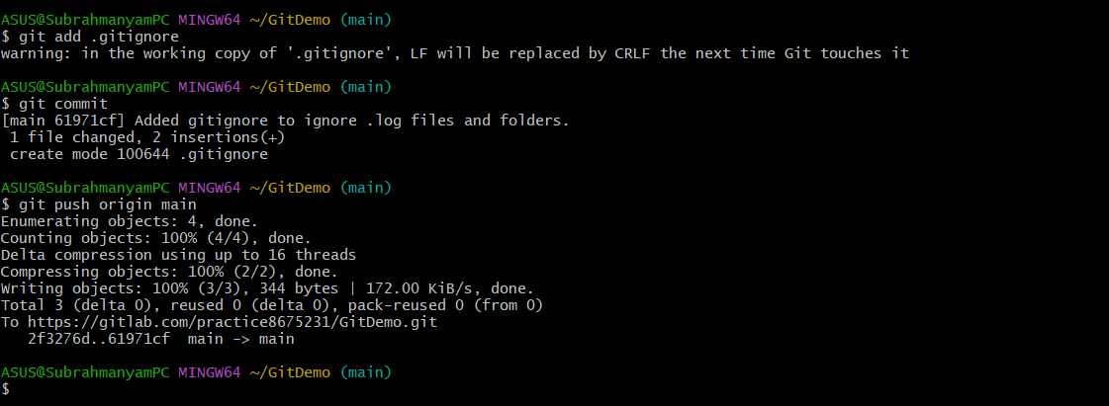

**Commit message in notepad++.**

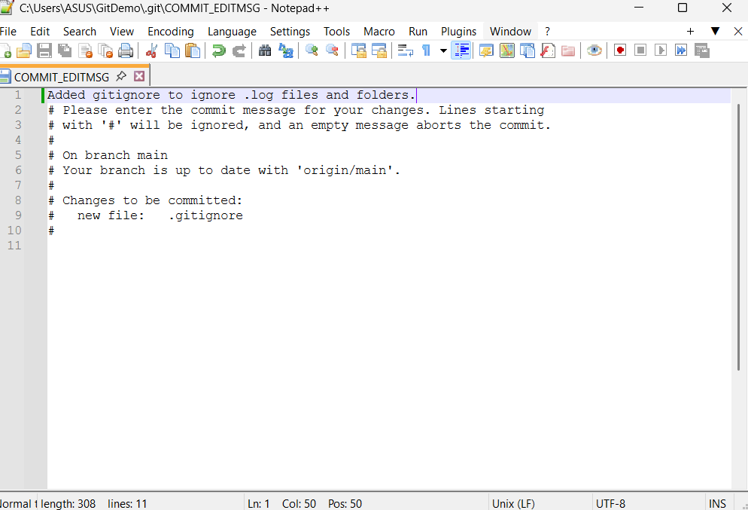

**Confirmation in all three, current working directory, local and remote repository**

